[malinimurthy123/FoodBoxDevOps at master (github.com)](https://github.com/malinimurthy123/FoodBoxDevOps/tree/master)

Course-end Project 1

DESCRIPTION

As a Full Stack Developer, you have to build a CI/CD pipeline to demonstrate continuous deployment and host the application on AWS EC2 instance.

**Background of the problem statement:**

As the project is in the final stage, management has asked you to automate the integration and deployment of the web application. You are required to set up an environment where the application will be hosted and accessed by users. The source code is supposed to be fetched from a GitHub repository.

**You must use the following:**

* Eclipse
* GitHub
* Jenkins
* AWS EC2/ Virtual machine

**Following requirements should be met:**

* A part of the source code should be tracked on the GitHub repository. You need to document the tracked files that are ignored during the final push to the GitHub repository.
* The submission of your GitHub repository link is mandatory. In order to track your task, you need to share the link of the repository in the document.
* The step-by-step process involved in completing this task should be documented.
  1. **Core concepts used in the project:**
  2. **Front End:**

HTML.

CSS3 and Bootstrap4. TypeScript.

Angular, Angular Material for View.

* 1. **VS Code:** As an IDE to design frontend of the application.
  2. **Git:** To connect and push files from the local system to GitHub.
  3. **GitHub:** To store the application code and track its versions
  4. **Scrum:** An efficient agile framework to deliver the product incrementally.
  5. **Back End:**

Eclipse IDE.

Java Programming.

Searching and Sorting Spring Boot DevTools.

Spring Web and Spring Data JPA.

* 1. **Testing and DevOps:**

Selenium.

Jenkins.

Amazon EC2 Instance

1. **EC2 Instance Creation And Setup.**
2. **Deploying Application on EC2 Instance**

**Step 01: EC2 Instance Creation And Setup**

**Step 02: Deploying Application on EC2 Instance**

**1. Connect with your Instance with your terminal**

**2. Prepare and Copy Project Build Using this command**

You will need to use your local terminal, not the instance terminal.

Just run this command to create a build.

$ ng build

Then run the below command according to your paths. You can follow my youtube video as well.

$ scp -r -i desktop/desktop/testall/staging_.pem ./path/to/files/   
 <username>@<public-ip-address>:/pathwhere/you/need/to/copy

**3. Update The Instance and Install Nginx:**

sudo yum update  
  
sudo yum install nginx  
  
sudo amazon-linux-extras install nginx1  
  
sudo systemctl start nginx  
  
sudo systemctl status nginx -l

You can confirm the Nginx setup by visiting your Public **IP address**in Browser.

Make sure HTTPS and HTTP Ports are allowed on EC2 Security Groups. As shown in my Youtube video. if you forget to allow it, Your IP address will not response.

**4. Update Nginx. conf file:**

Run this command to open Nginx.conf file

$sudo vim /etc/nginx/nginx.conf # run this command

Add these lines in the Nginx configuration file.

location / {  
 autoindex on;  
 root /home/ec2-user/web;  
 try_files $uri /index.html;  
 }  
 root /usr/share/nginx/html;

**5. Give Some permissions**

namei -om /usr/share/nginx/html  
 namei -om /home/ec2-user/YourBuildName  
 sudo chmod 755 /home/ec2-user  
 namei -om /home/ec2-user/YourBuildName

**5. Reload The**

sudo systemctl reload nginx  
sudo systemctl restart nginx

**6. Open The website Using your Instance IP Address in the Browser:**

EC2 Instance Running:

ec2-user

54.196.182.51

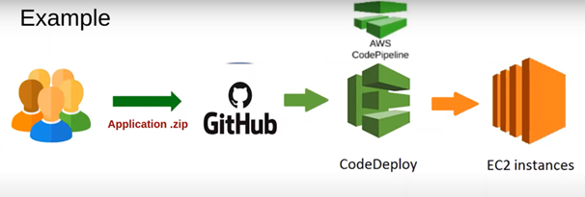

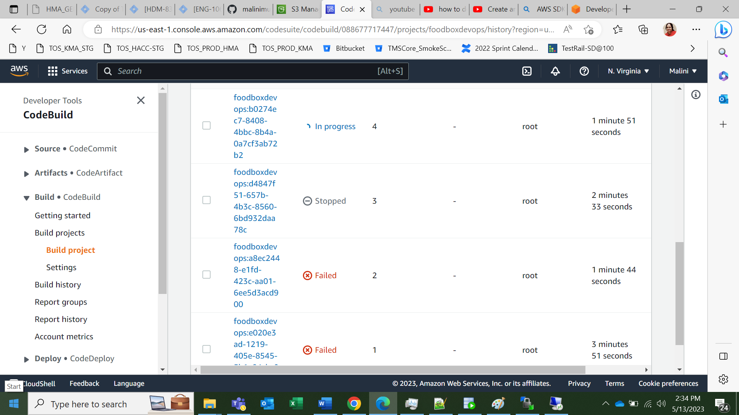

location / {  
 autoindex on;  
 root /home/ec2-user/foodbox;  
 try_files $uri /index.html;  
 }  
 root /usr/share/nginx/html;

namei -om /usr/share/nginx/html  
 namei -om /home/ec2-user/foodbox  
 sudo chmod 755 /home/ec2-user  
 namei -om /home/ec2-user/foodbox

